DIGITAL SIGNAL PROCESSING – ECA0902
MS1 - JULY – 2026 – SLOT C – Keerthi Kassan V

Name: Saravana Yogesh M
Regno: 192412273

MATLAB EXPERIMENTS OUTPUT

EXPERIMENT 1
1.Butterworth IIR Filters
1.1. Design and Analysis of a Butterworth IIR Low-Pass Filter Using MATLAB.
1.2. Design and Analysis of a Butterworth IIR High-Pass Filter Using MATLAB.

  - CODE:

clc; clear
Fs=10000; Fp=1000; Fst=1500;
[N,Wn]=buttord(Fp/(Fs/2),Fst/(Fs/2),1,60);
[b,a]=butter(N,Wn);
freqz(b,a) % Magnitude & Phase
figure
[h,n]=impz(b,a,50);
...title('Impulse Response')
figure
stepz(b,a)
figure
zplane(b,a)
fprintf('Minimum Filter Order (N) = %d\n',N);
fprintf('Cutoff Frequency (Wn) = %.4f\n',Wn);

OUTPUT:

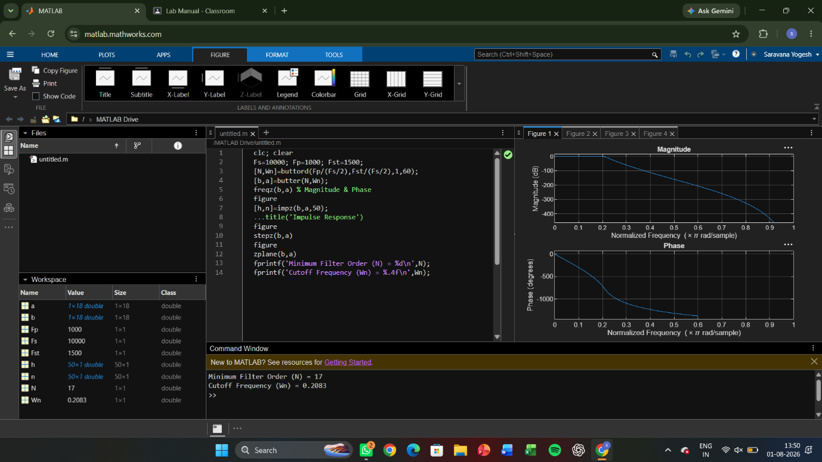
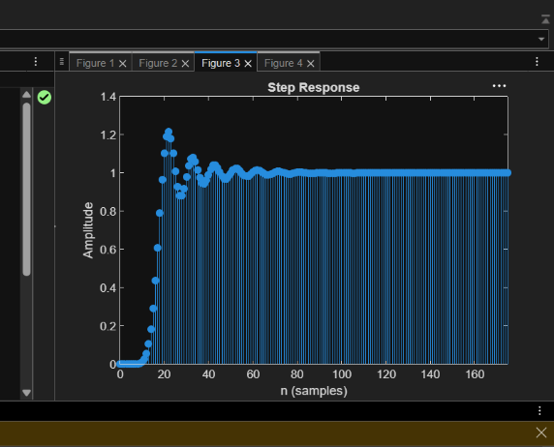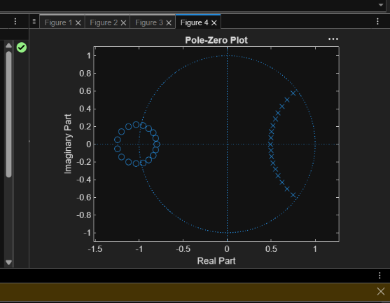

1.2)CODE:
clc; clear
Fs=10000; Fp=3000; Fst=2000;
[N,Wn]=buttord(Fp/(Fs/2),Fst/(Fs/2),1,60);
[b,a]=butter(N,Wn,'high');
% Magnitude & Phase
freqz(b,a)
% Impulse Response
figure
[h,n]=impz(b,a,50);
stem(n,h), grid on
title('Impulse Response')
% Step Response
figure
stepz(b,a)
title('Step Response')
% Group Delay
figure
grpdelay(b,a)
title('Group Delay')
% Pole-Zero Plot
figure
zplane(b,a)
title('Pole-Zero Plot')
fprintf('Minimum Filter Order (N) = %d\n',N);
fprintf('Cutoff Frequency (Wn) = %.4f\n',Wn);

OUTPUT:

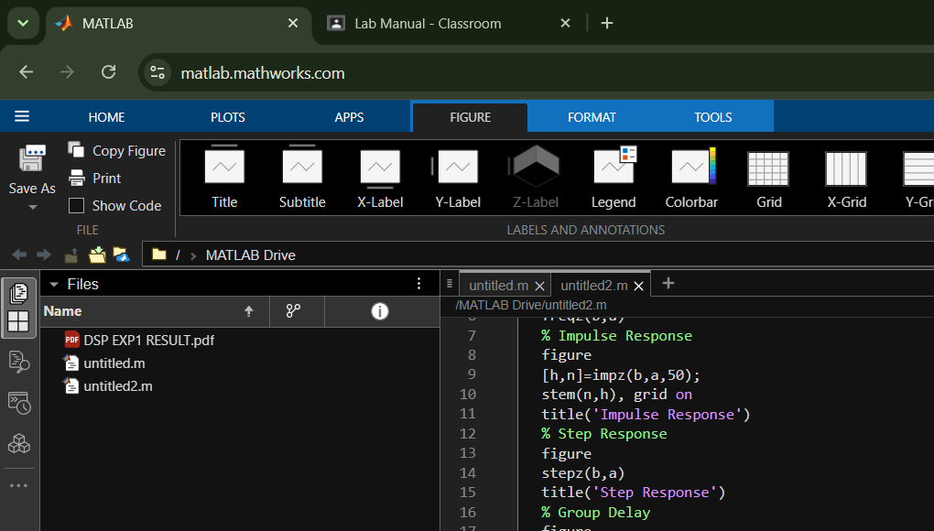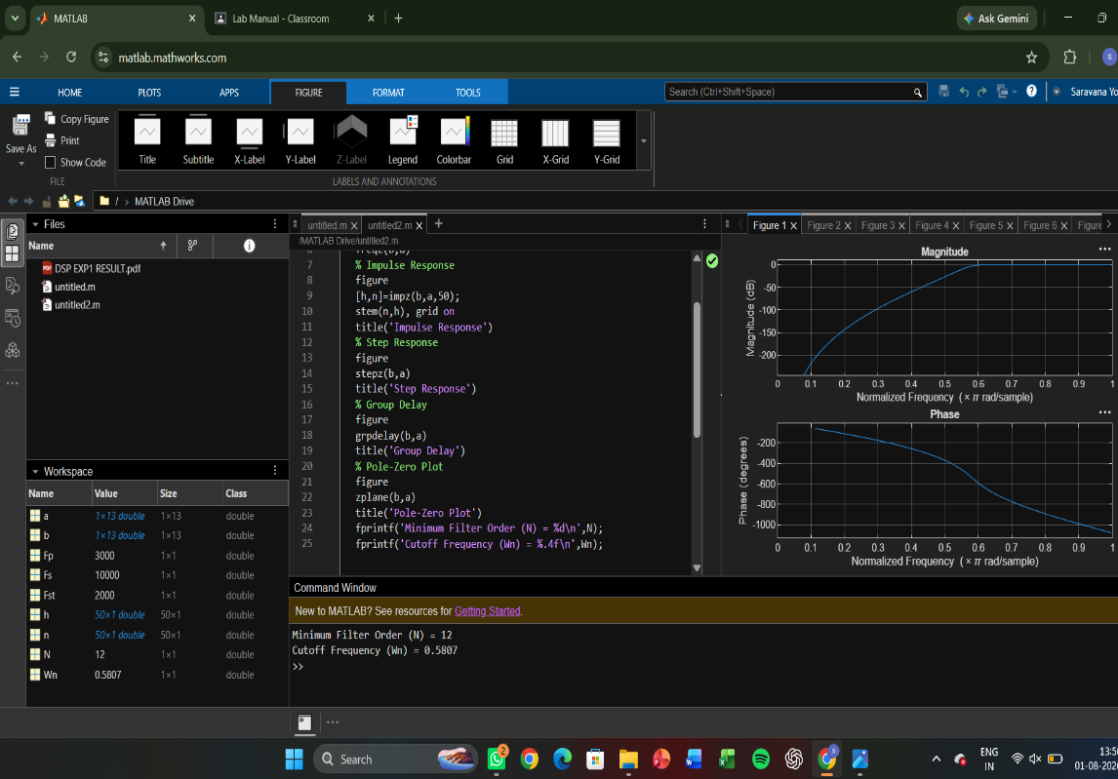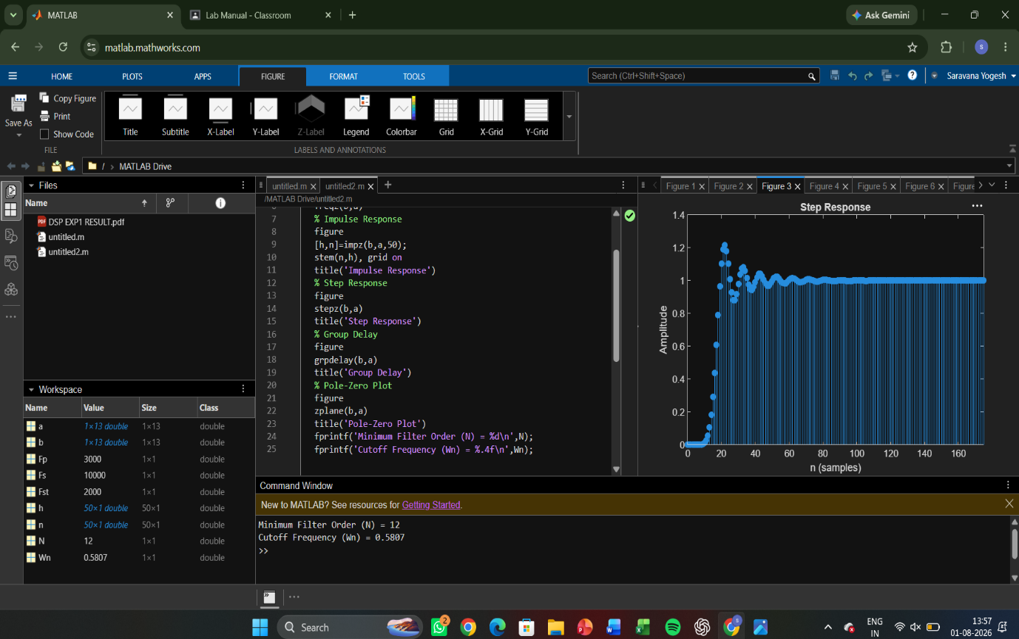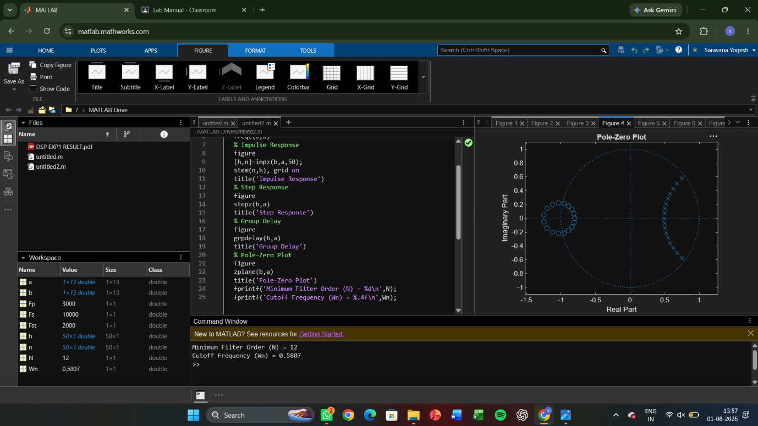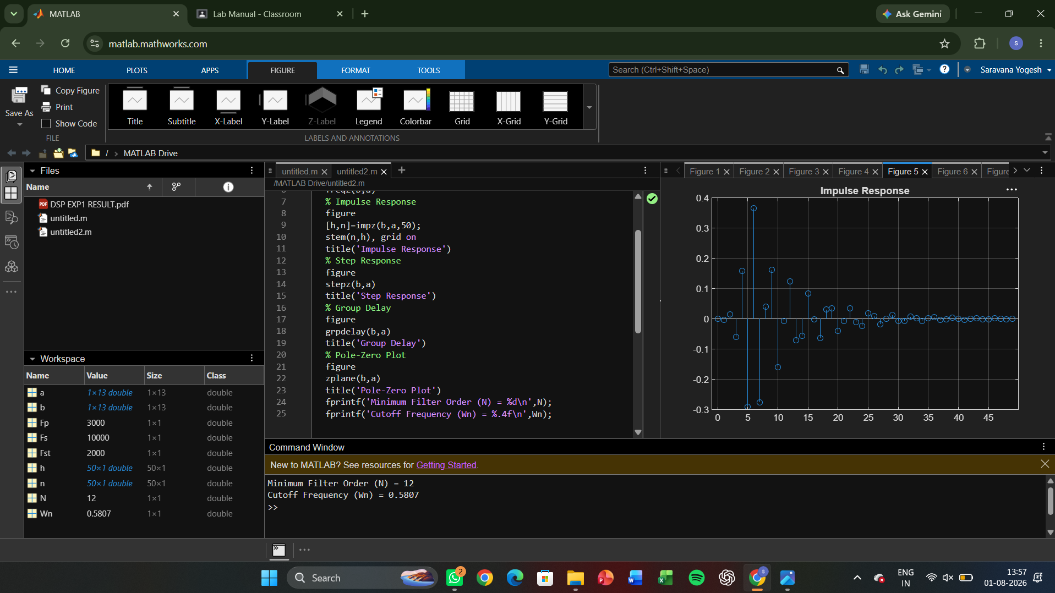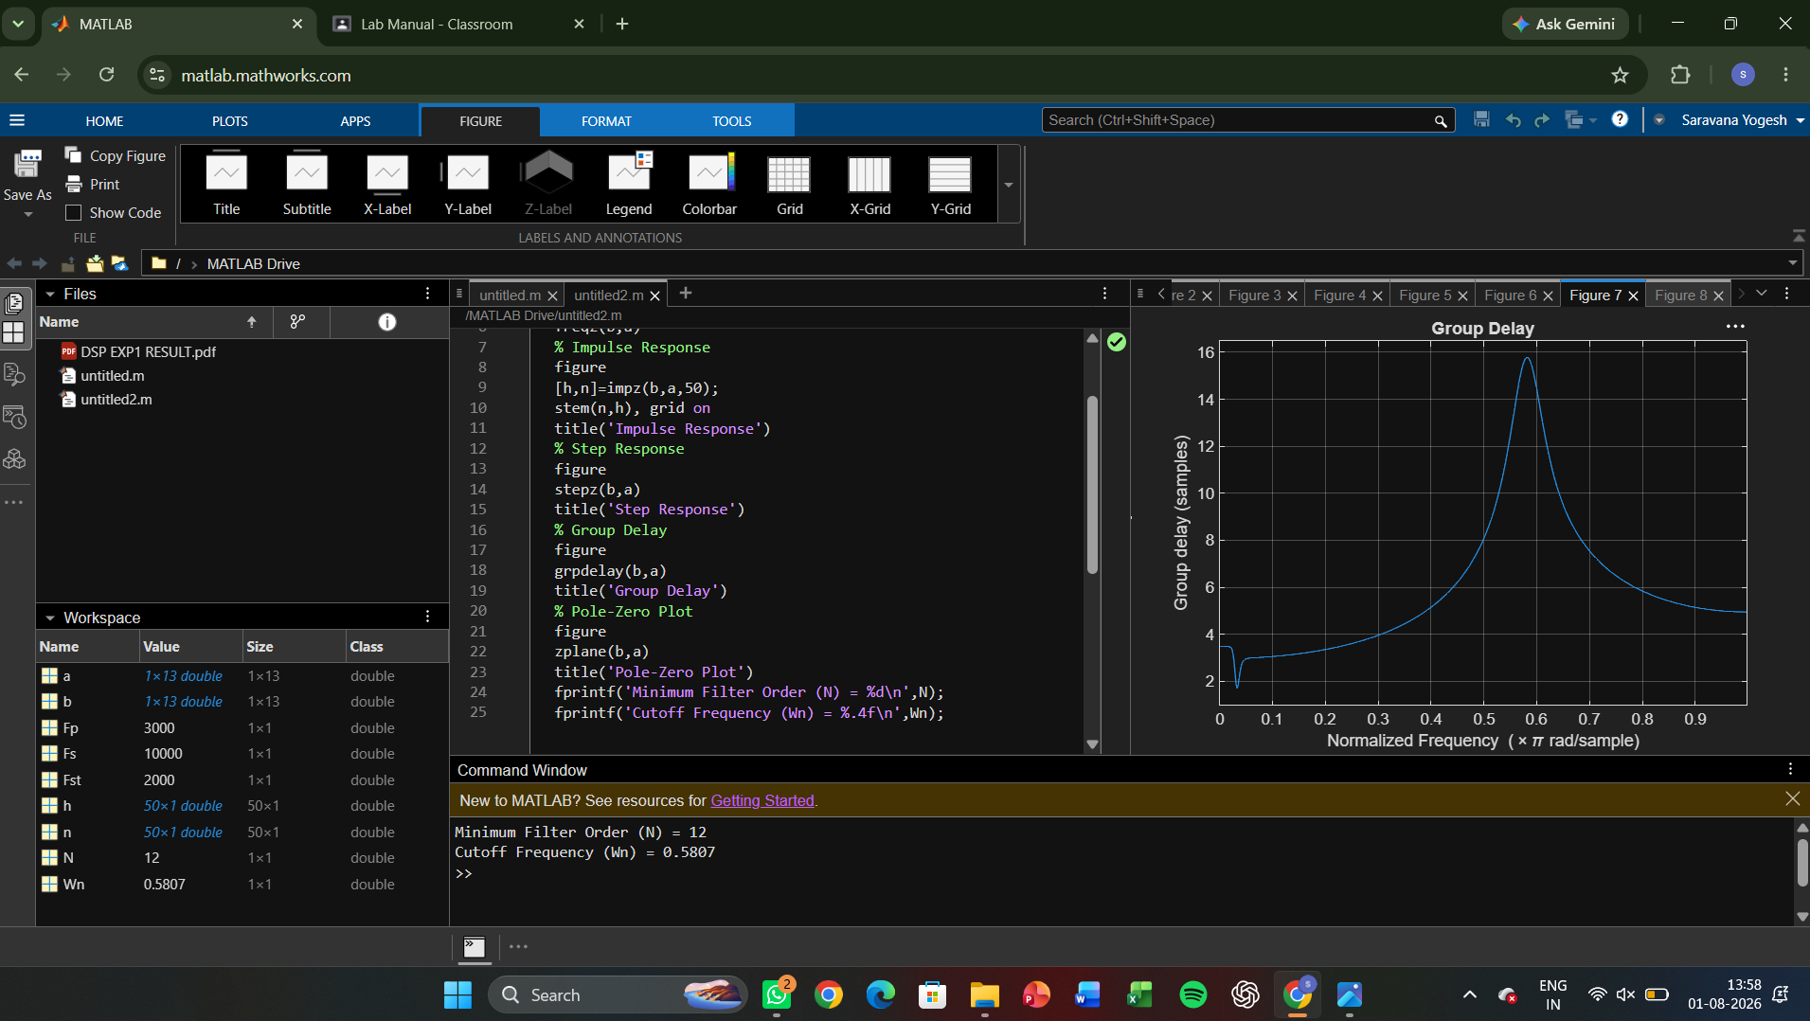

EXPERIMENT 2

2.Chebyshev IIR Filters
2.1 Design and performance Evaluation of a Chebyshev Type I IIR Low Pass Filter using MATLAB
2.2 Design and performance Evaluation of a Chebyshev Type I IR High Pass Filter using MATLAB

2.1) CODE:

clc; clear;
[N,Wn]=cheb1ord(Wp,Ws,Rp,As);
[b,a]=cheby1(N,Rp,Wn);
fprintf('Filter Order = %d\n',N);
fprintf('Cutoff Frequency = %.2f * pi rad/sample\n',Wn);
if all(abs(roots(a))<1)
disp('System is STABLE');
else
disp('System is UNSTABLE');
end

OUTPUT
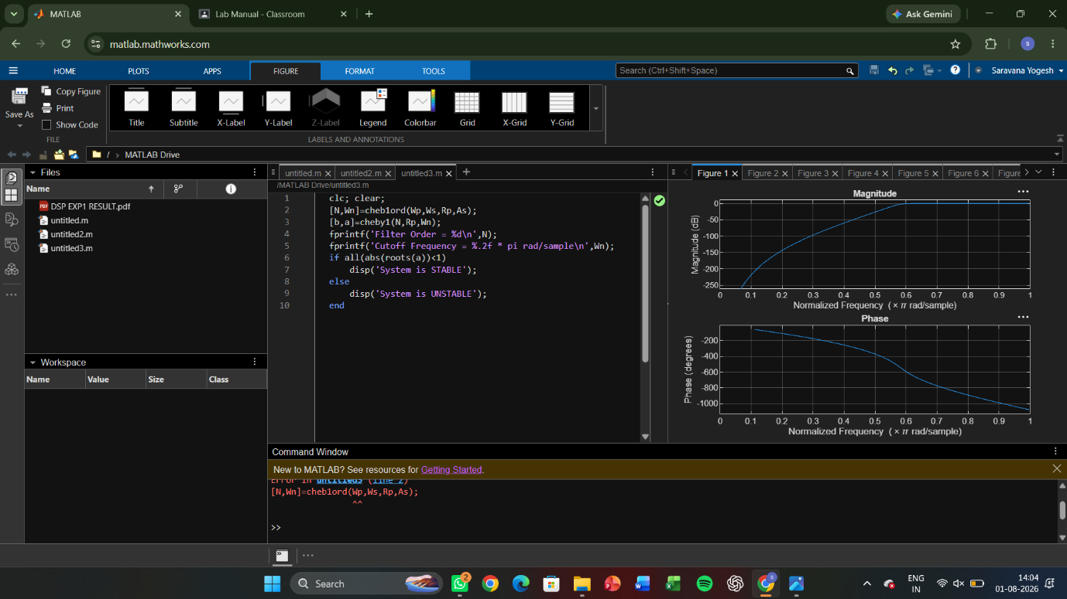

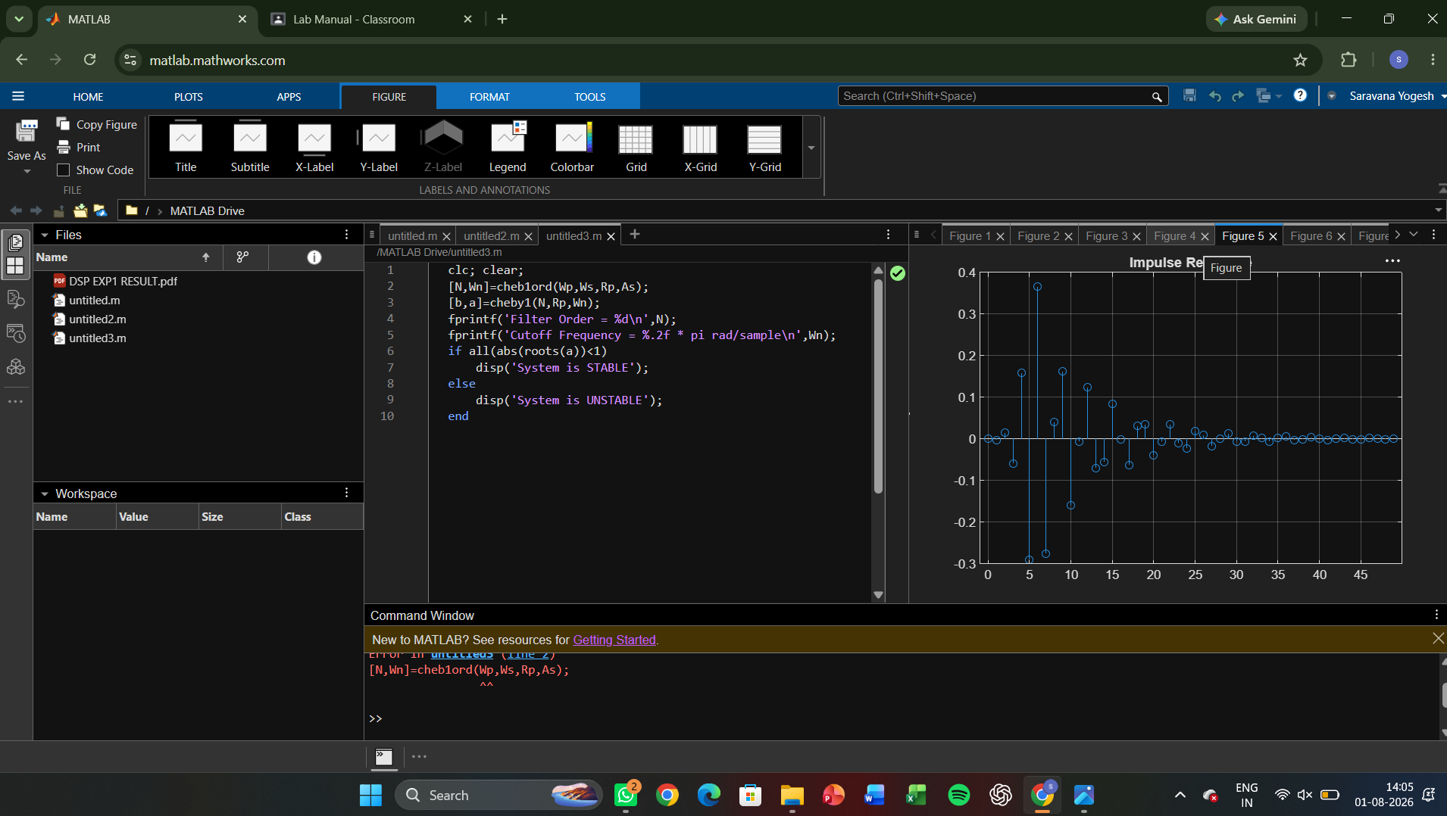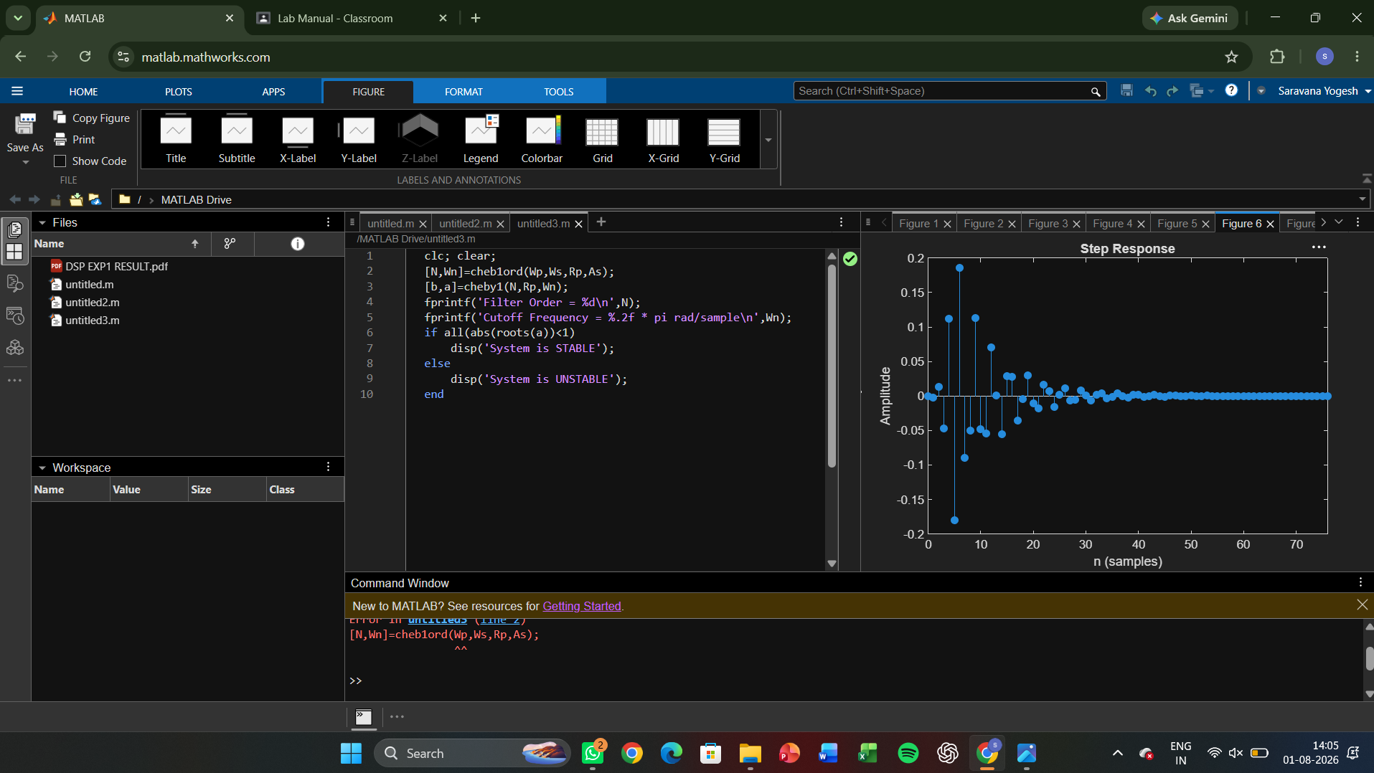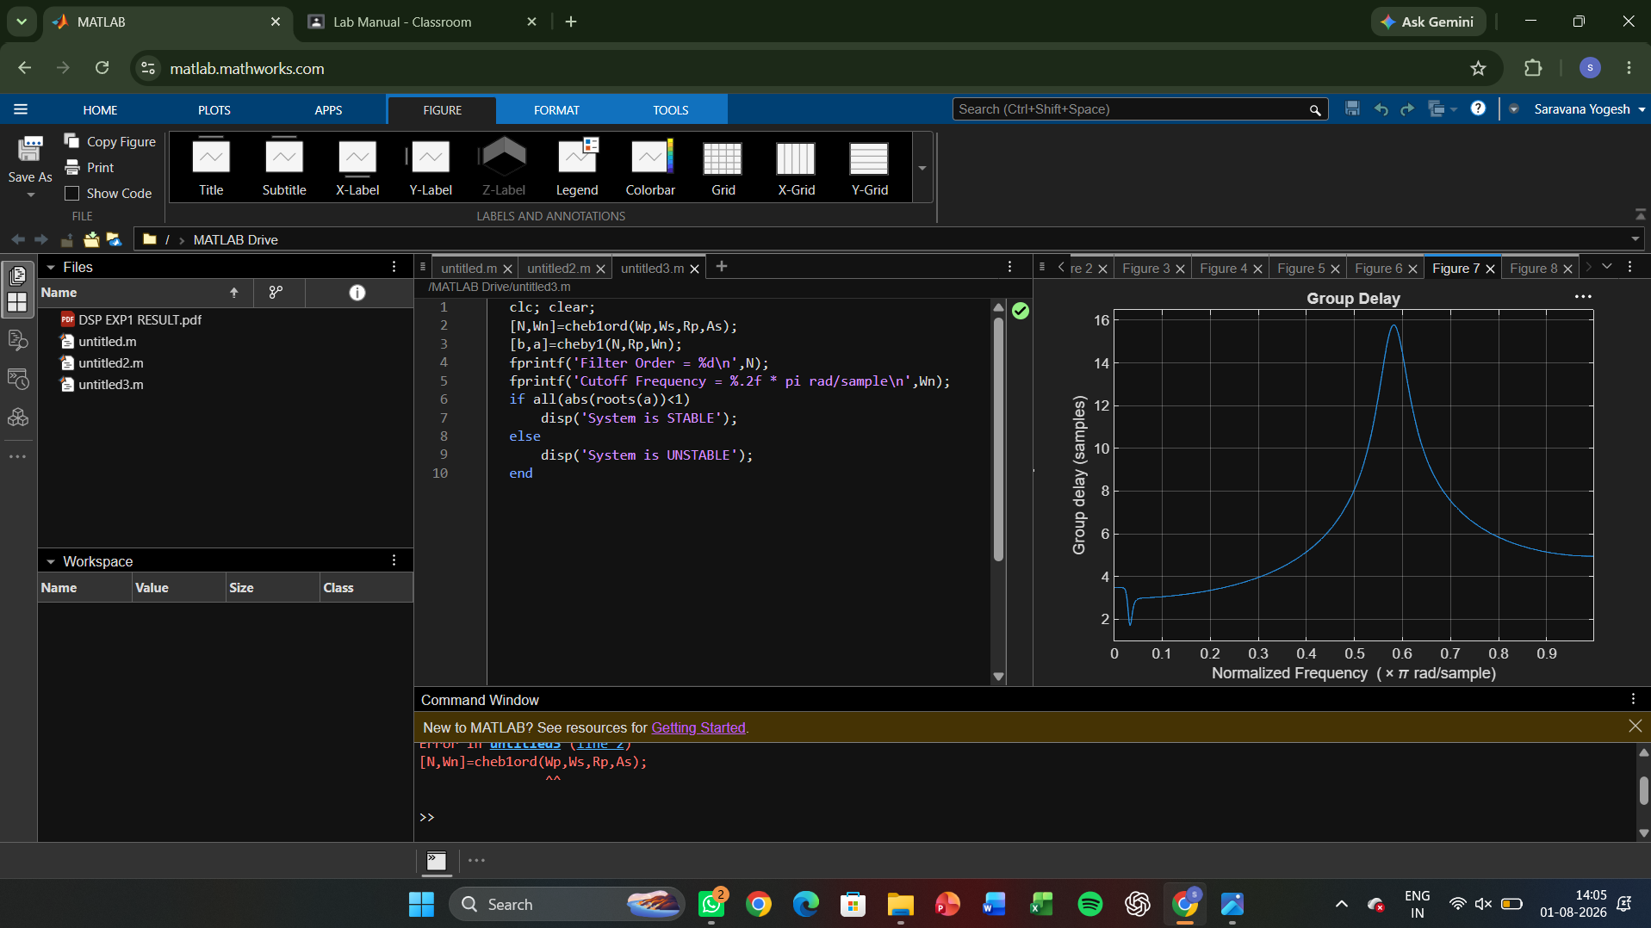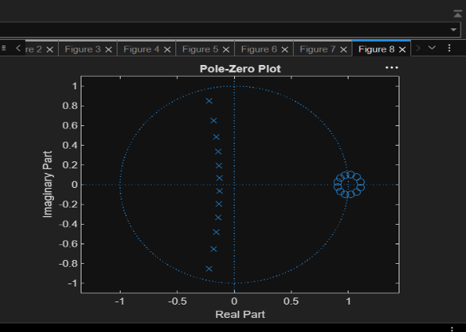
2.2)CODE:

clc;
clear;
close all;
% Specifications
Rp = 1; % Passband Ripple (dB)
Rs = 40; % Stopband Attenuation (dB)
Wp = 0.5; % Passband Edge
Ws = 0.35; % Stopband Edge
% Find Filter Order
[n,Wn] = cheb1ord(Wp,Ws,Rp,Rs);
% Design High-Pass Filter
[b,a] = cheby1(n,Rp,Wn,'high');
% Frequency Response
figure;
freqz(b,a);
title('Frequency Response');
% Impulse Response
figure;
impz(b,a);
title('Impulse Response');
% Group Delay
figure;
grpdelay(b,a);
title('Group Delay');
% Pole-Zero Plot
figure;
zplane(b,a);
title('Pole-Zero Plot');
fprintf('Filter Order = %d\n',n);
fprintf('Cutoff Frequency = %.4f\n',Wn);
OUTPUT:
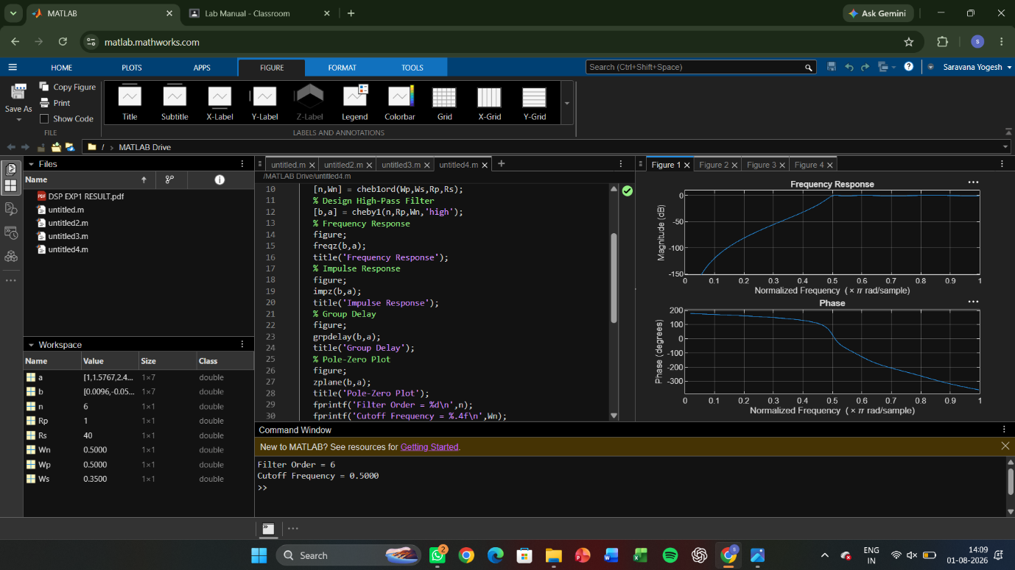

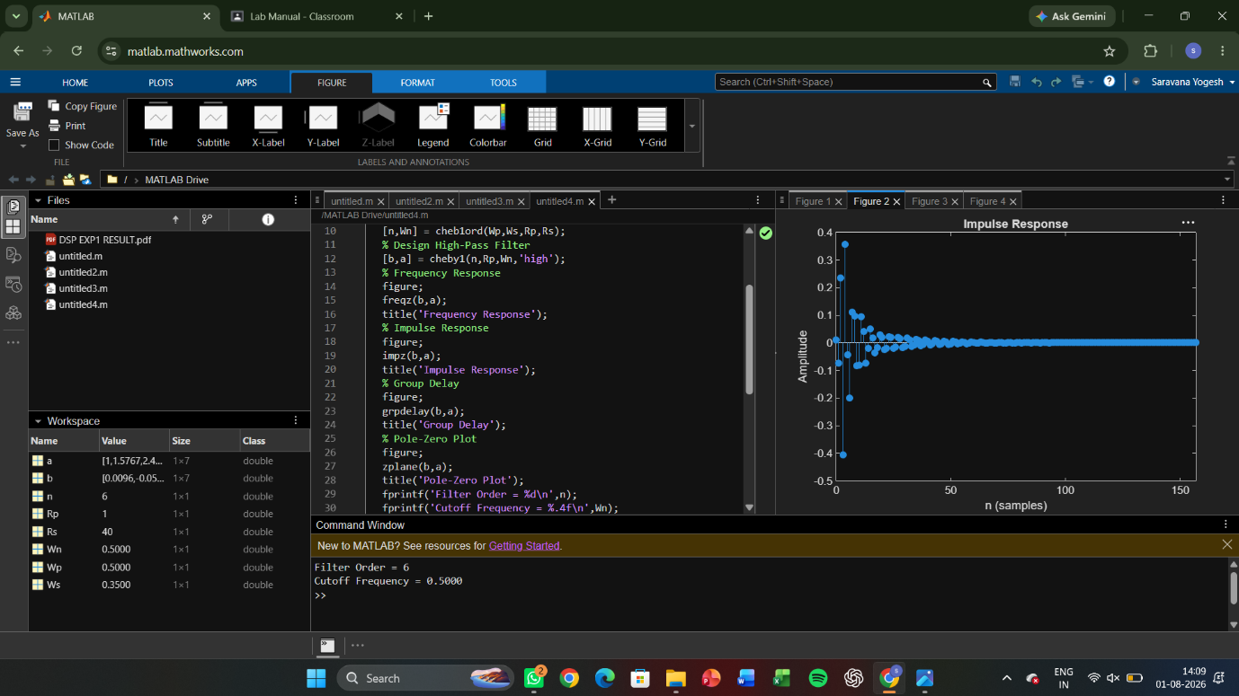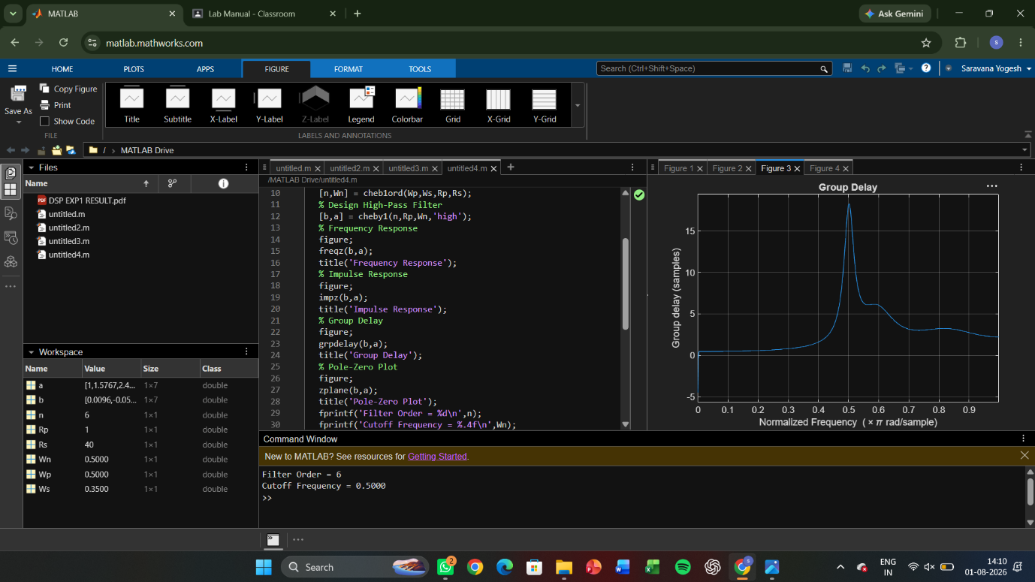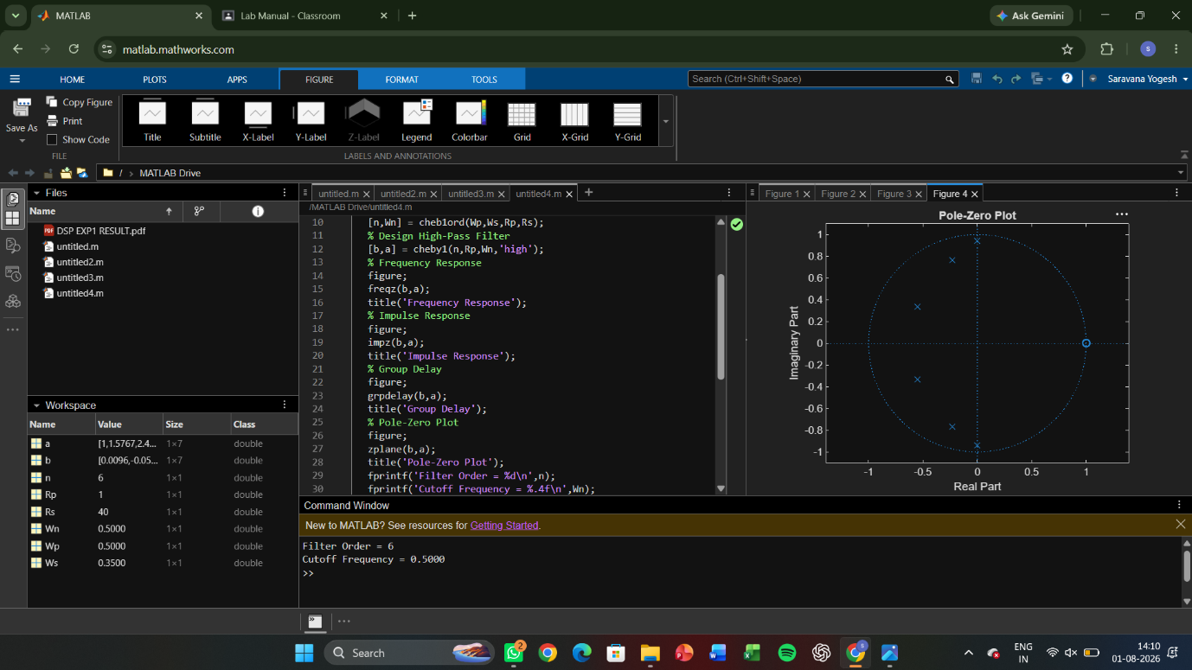

EXPERIMENT 3
3. Performance Analysis of IIR Filters.
3.1 Design and Comparative Analysis of Butterworth and Chebyshev Type-I IIR Band-Pass Filters Using MATLAB
3.1) CODE
clc; clear; close all;
% Specifications
Fs=2000; Rp=1; Rs=40;
Wp=[300 600]/(Fs/2);
Ws=[200 700]/(Fs/2);
% Butterworth Filter
[n1,W1]=buttord(Wp,Ws,Rp,Rs);
[b1,a1]=butter(n1,W1,'bandpass');
% Chebyshev Type-I Filter
[n2,W2]=cheb1ord(Wp,Ws,Rp,Rs);
[b2,a2]=cheby1(n2,Rp,W2,'bandpass');
% Magnitude Response
figure;
freqz(b1,a1); title('Butterworth Filter');
figure;
freqz(b2,a2); title('Chebyshev Type-I Filter');
% Group Delay
figure;
grpdelay(b1,a1); hold on;
grpdelay(b2,a2);
legend('Butterworth','Chebyshev-I');
% Pole-Zero Plot
figure;
subplot(121),zplane(b1,a1),title('Butterworth')
subplot(122),zplane(b2,a2),title('Chebyshev-I')
% Impulse Response
figure;
subplot(211),impz(b1,a1),title('Butterworth Impulse')
subplot(212),impz(b2,a2),title('Chebyshev Impulse')
% Pole Magnitude
figure;
subplot(121),stem(abs(roots(a1)),'filled')
title('Butterworth Pole Magnitude')
subplot(122),stem(abs(roots(a2)),'filled')
title('Chebyshev Pole Magnitude')
disp(['Butterworth Order = ',num2str(n1)])
disp(['Chebyshev Order = ',num2str(n2)])

OUTPUT:
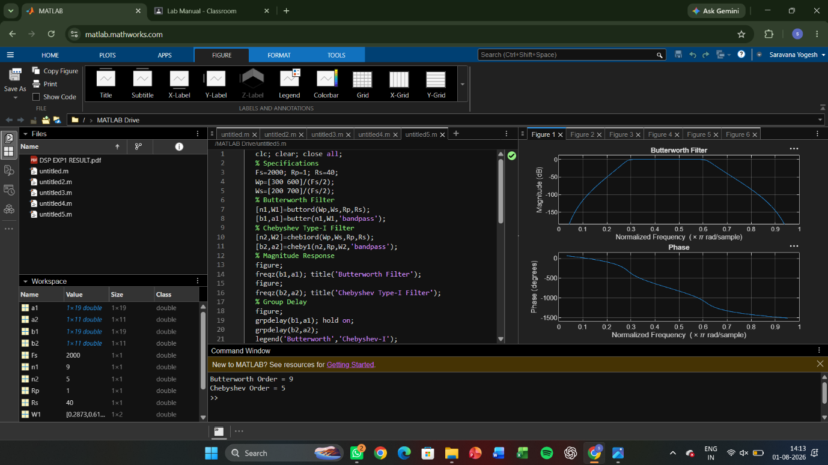

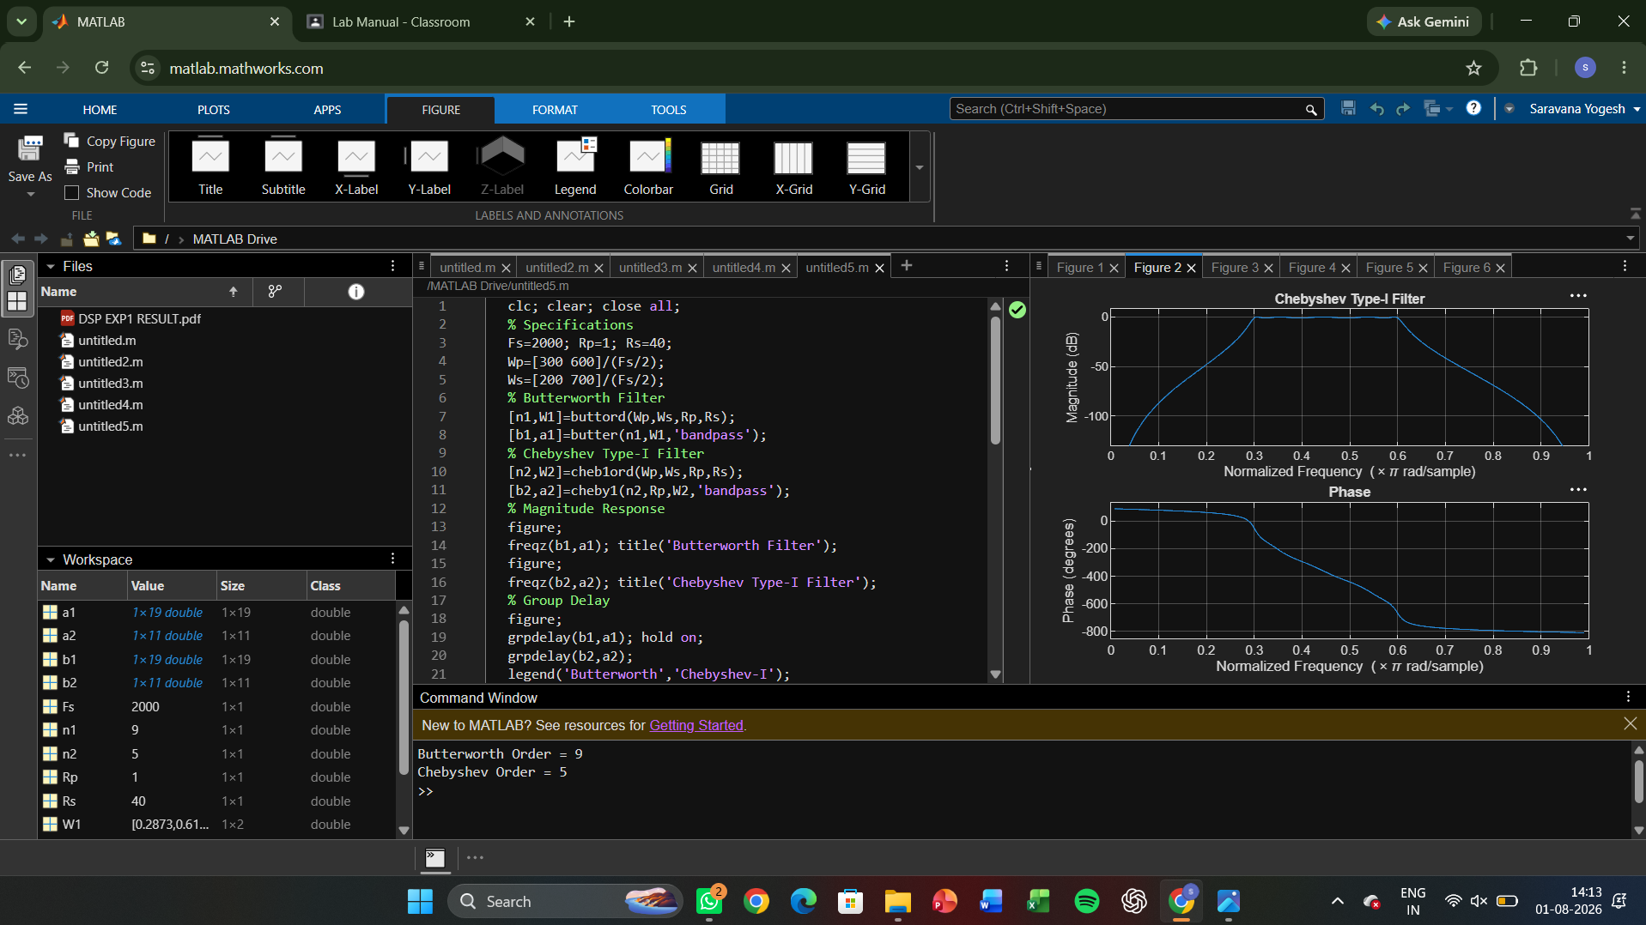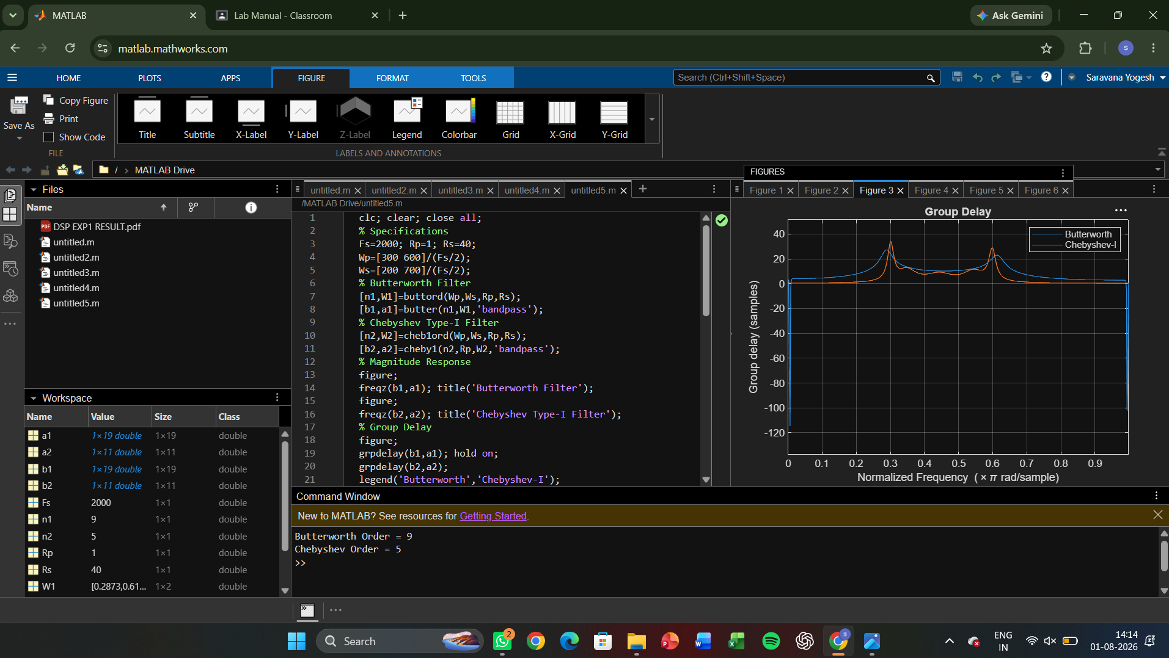
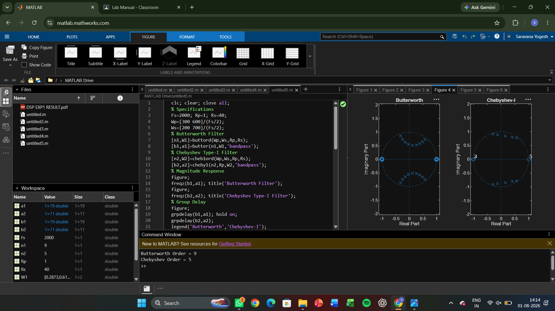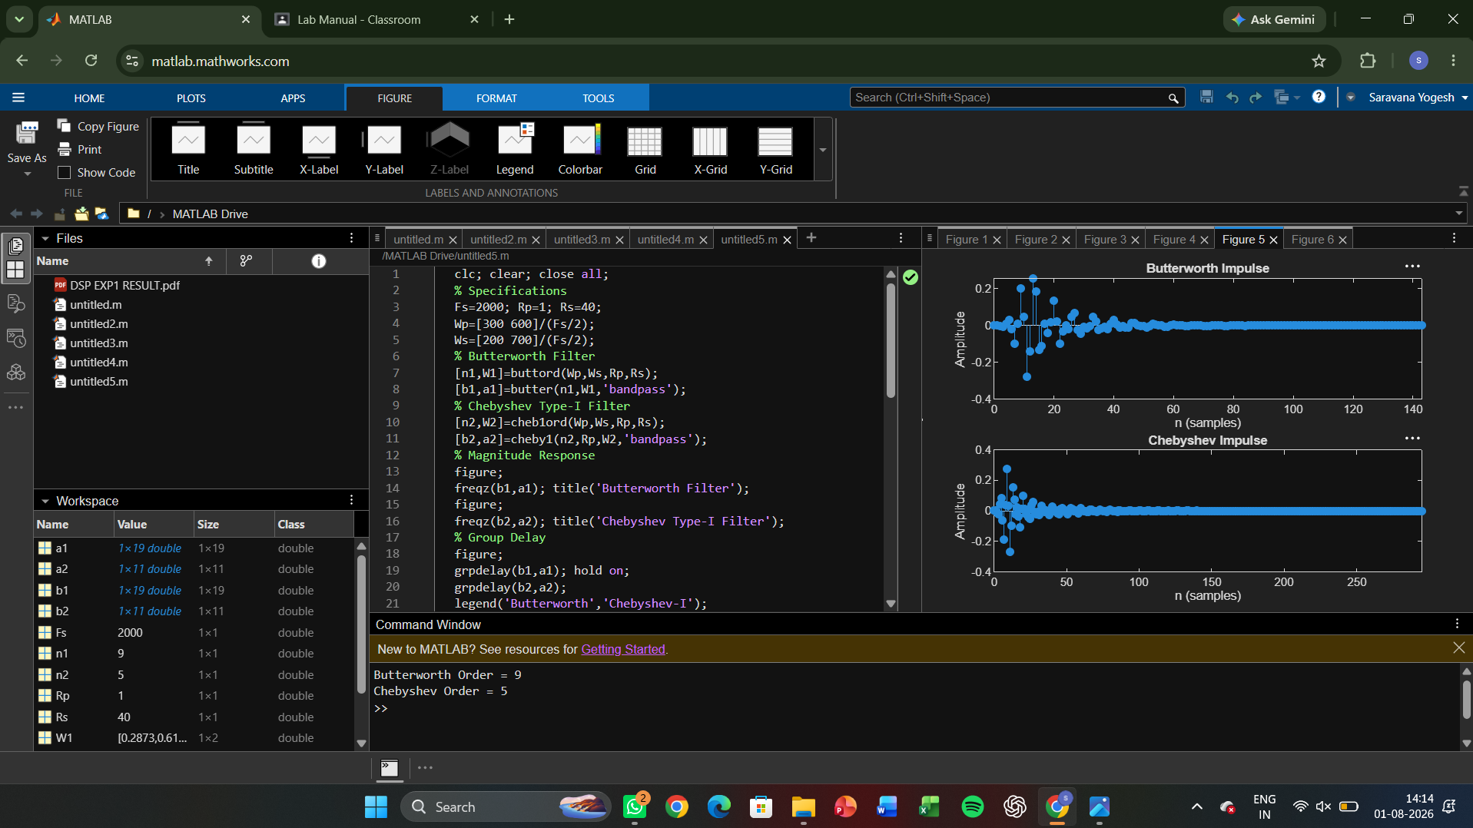

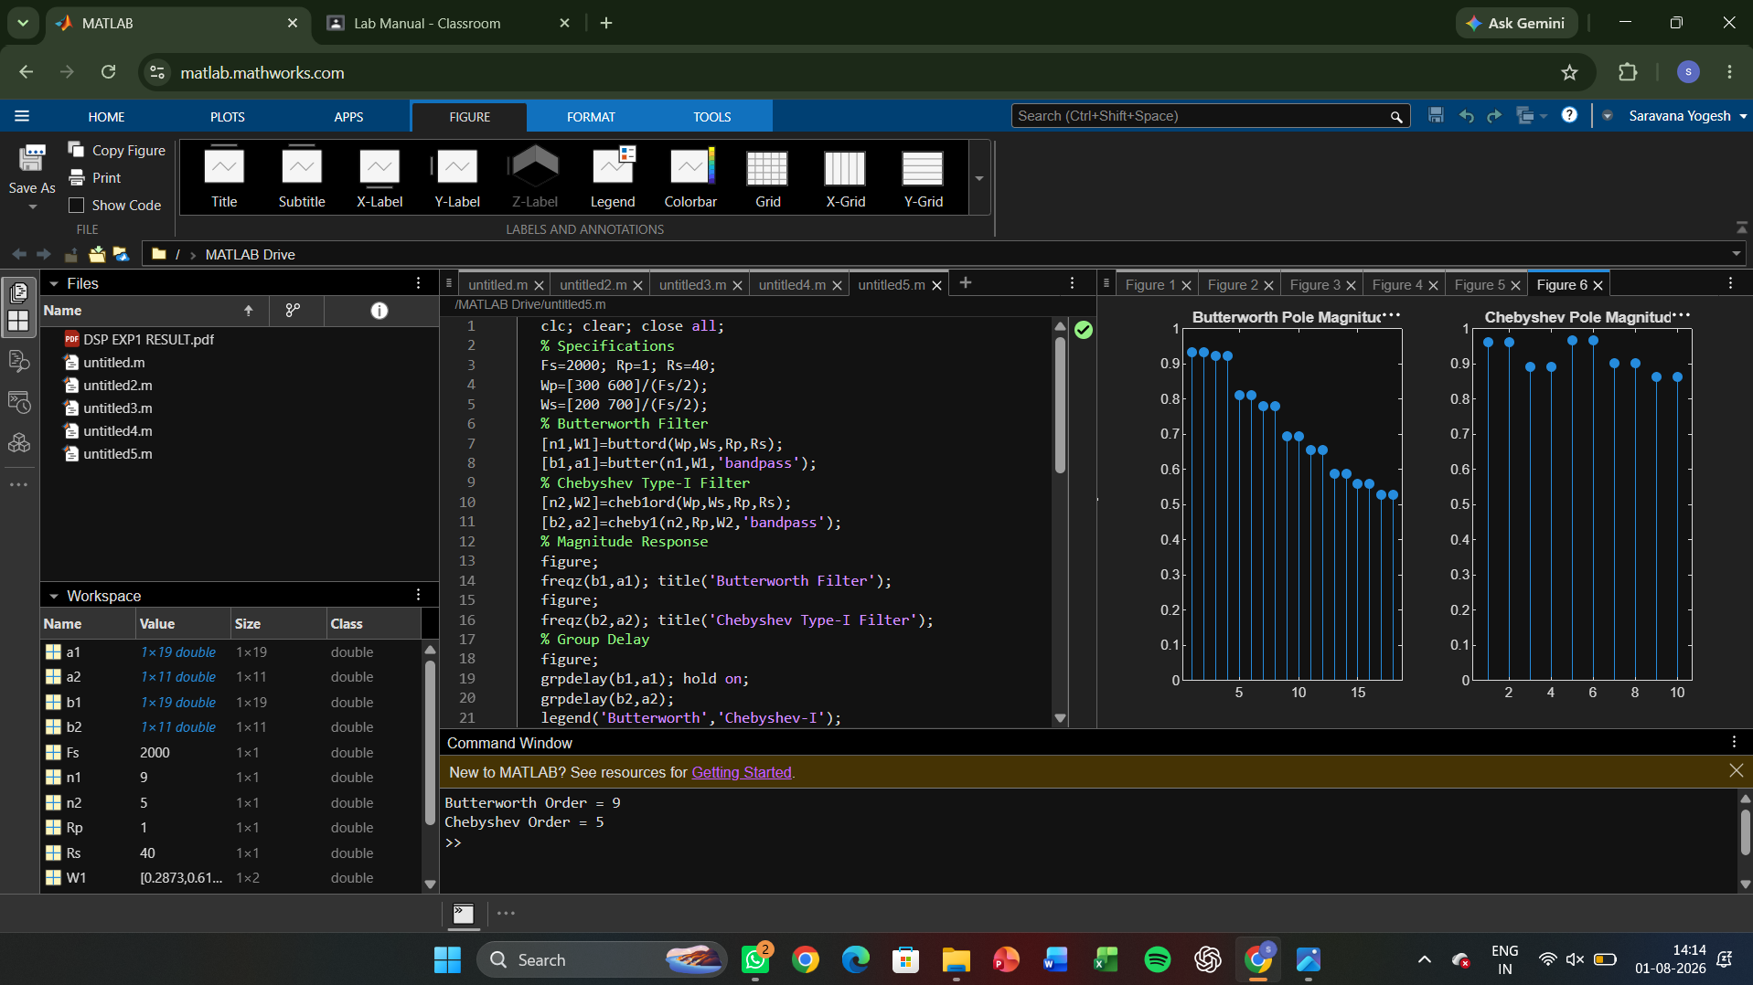

EXPERIMENT 4

4. FIR Low Pass FilterS using Windowing Techniques
4.1. Design and Analysis of an FIR Low-Pass Filter Using the Rectangular Window Technique in MATLAB.
4.2. Design and Analysis of an FIR Low-Pass Filter Using the Hamming Window Technique in MATLAB.
4.3. Design and Analysis of an FIR Low-Pass Filter Using the Hanning Window Technique in MATLAB.
4.1)CODE:
clc;
clear;
close all;
%% --- Input Parameters ---
fp = 1000; % Passband cutoff (Hz)
fs = 4000; % Sampling frequency (Hz)
N = 50; % Filter order (even number preferred)

wc = fp/(fs/2); % Normalized cutoff frequency (0 to 1)
%% --- 1. FIR Low Pass using Rectangular Window ---
b_rect = fir1(N, wc, 'low', rectwin(N+1));
disp('--- Rectangular Window Coefficients ---');
disp(b_rect');
%% --- 2. FIR Low Pass using Hamming Window ---
b_hamm = fir1(N, wc, 'low', hamming(N+1));
disp('--- Hamming Window Coefficients ---');
disp(b_hamm');
%% --- 3. FIR Low Pass using Hanning Window ---
b_hann = fir1(N, wc, 'low', hanning(N+1));
disp('--- Hanning Window Coefficients ---');
disp(b_hann');
%% --- Plot Frequency Responses ---
figure;
freqz(b_rect,1);
title('Low-pass FIR using Rectangular Window');
figure;
freqz(b_hamm,1);
title('Low-pass FIR using Hamming Window');
figure;
freqz(b_hann,1);
title('Low-pass FIR using Hanning Window');
OUTPUT;
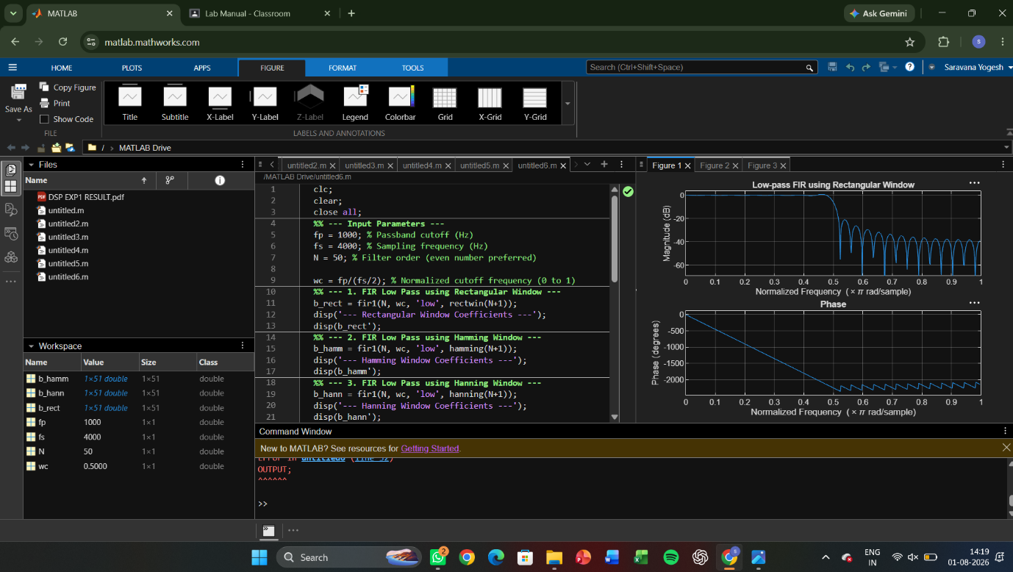

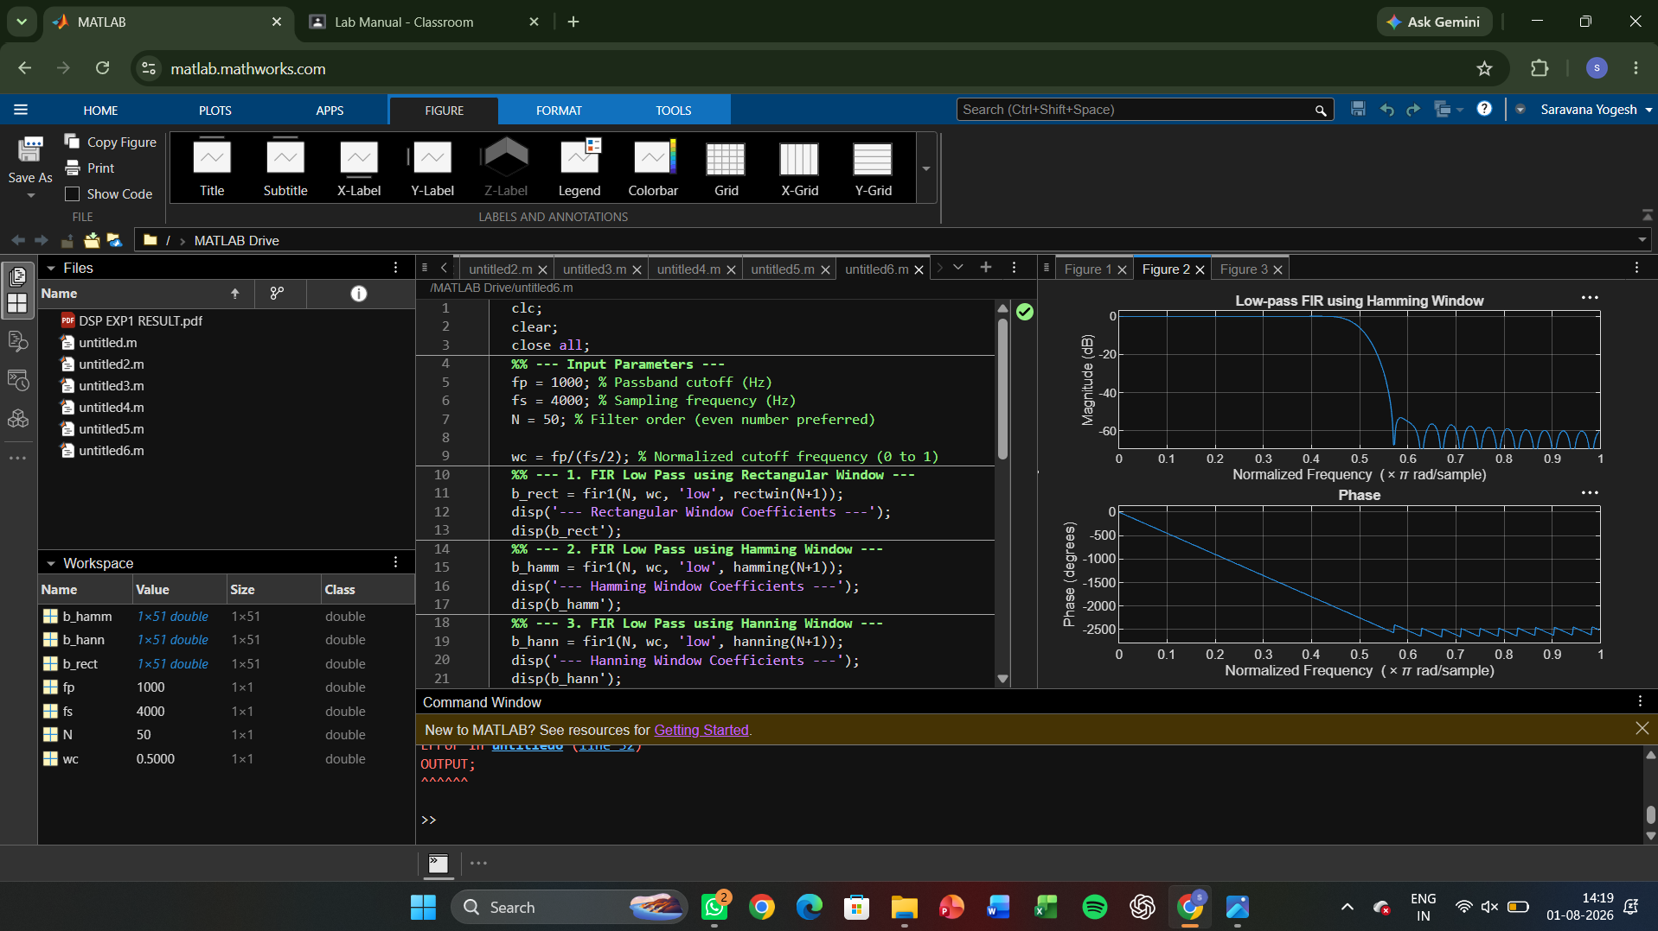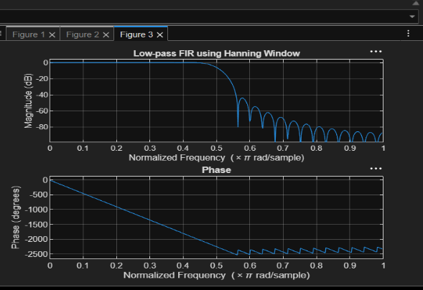
4.2) CODE:

clc;
clear;
close all;
%% --- Input Parameters ---
fp = 1000; % Passband cutoff (Hz)
fs = 4000; % Sampling frequency (Hz)
N = 50; % Filter order (even number preferred)
wc = fp/(fs/2); % Normalized cutoff frequency (0 to 1)
%% --- FIR Low Pass using Hamming Window ---
b_hamm = fir1(N, wc, 'low', hamming(N+1));
disp('--- Hamming Window Coefficients ---');
disp(b_hamm');
%% --- Plot Frequency Responses ---
figure;
freqz(b_hamm,1);
title('Low-pass FIR using Hamming Window');

OUTPUT

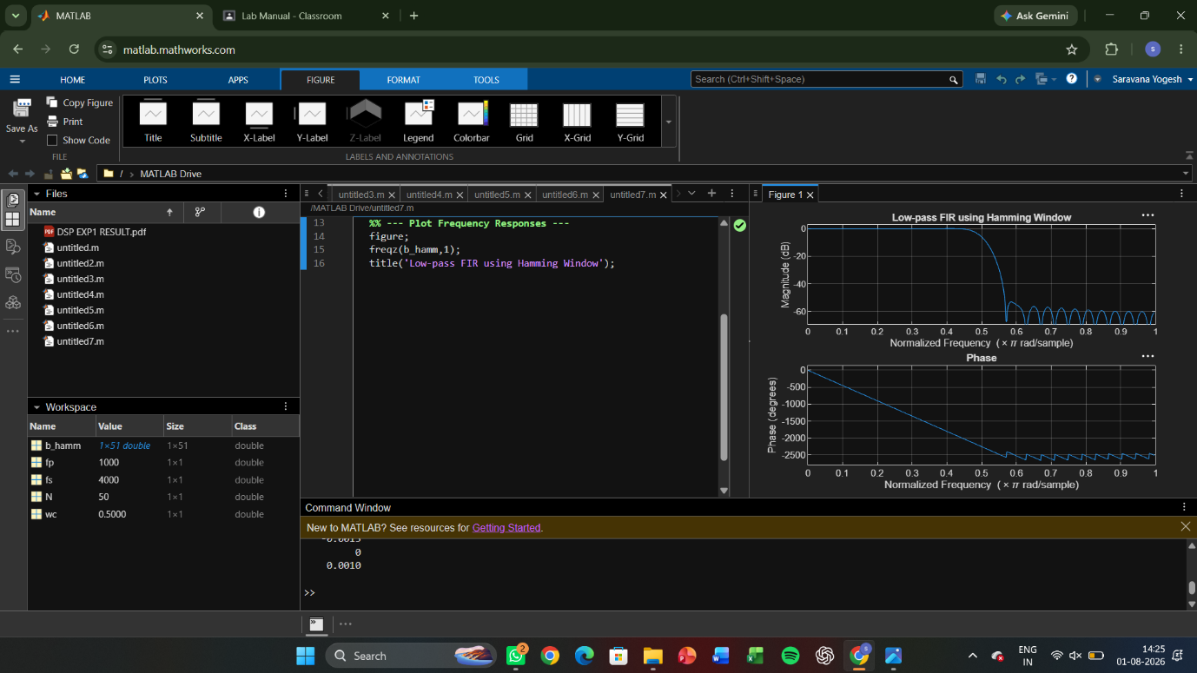

4.3)CODE:

clc;
clear;
close all;
%% --- Input Parameters ---
fp = 1000; % Passband cutoff (Hz)
fs = 4000; % Sampling frequency (Hz)
N = 50; % Filter order (even number preferred)
wc = fp/(fs/2); % Normalized cutoff frequency (0 to 1)

%% --- FIR Low Pass using Hanning Window ---
b_hann = fir1(N, wc, 'low', hanning(N+1));
disp('--- Hanning Window Coefficients ---');
disp(b_hann');
%% --- Plot Frequency Responses ---
figure;
freqz(b_hann,1);
title('Low-pass FIR using Hanning Window');

OUTPUT

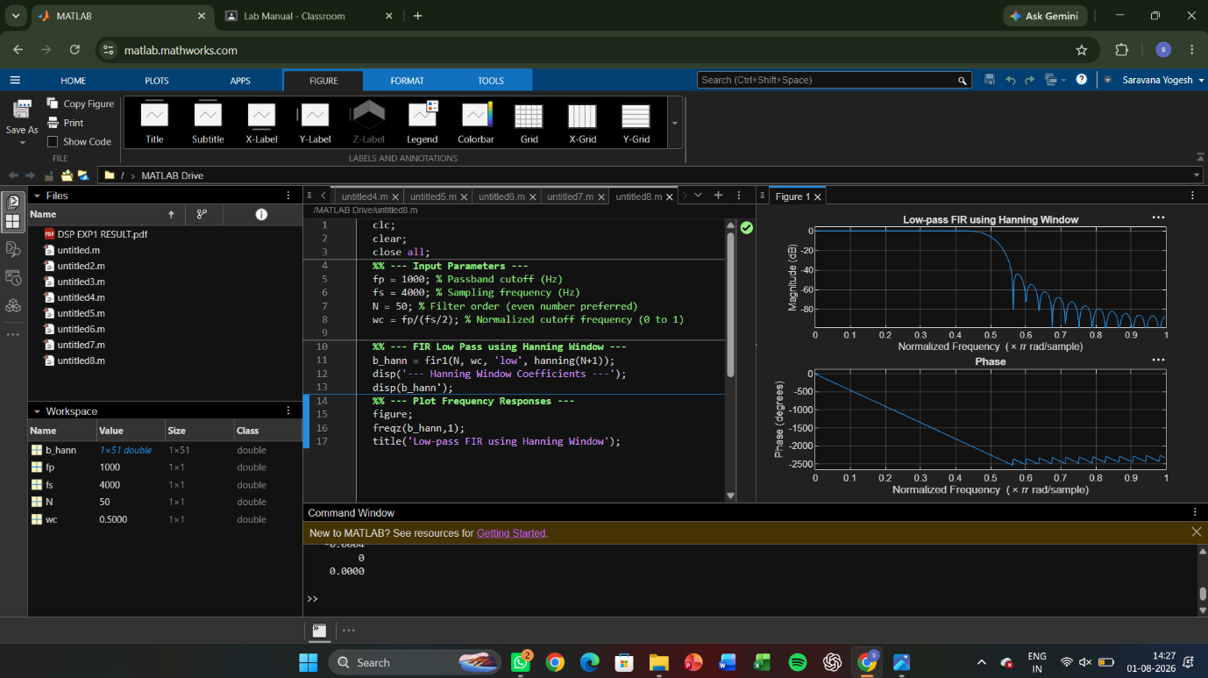

EXPERIMENT 5
5. FIR High Pass FilterS using Windowing Techniques
5.1. Design and Analysis of an FIR High-Pass Filter Using the Rectangular Window Technique in MATLAB.
5.2. Design and Analysis of an FIR High-Pass Filter Using the Hamming Window Technique in MATLAB. .
5.3. Design and Analysis of an FIR High-Pass Filter Using the Hanning Window Technique in MATLAB.

5.1)CODE

clc; clear; close all;
%% --- Input Parameters ---
fp = 1000; % High-pass cutoff frequency (Hz)
fs = 8000; % Sampling frequency (Hz)
N = 50; % Filter order

wc = fp/(fs/2); % Normalized cutoff (0–1)

%% --- 1. FIR High Pass using Rectangular Window ---
b_rect = fir1(N, wc, 'high', rectwin(N+1));
disp('--- High-Pass Coefficients (Rectangular Window) ---');
disp(b_rect');

%% --- 2. FIR High Pass using Hamming Window ---
b_hamm = fir1(N, wc, 'high', hamming(N+1));
disp('--- High-Pass Coefficients (Hamming Window) ---');
disp(b_hamm');
%% --- 3. FIR High Pass using Hanning Window ---
b_hann = fir1(N, wc, 'high', hanning(N+1));
disp('--- High-Pass Coefficients (Hanning Window) ---');
disp(b_hann');
%% --- Frequency Response Plots ---
figure;
freqz(b_rect,1);
title('High-pass FIR using Rectangular Window');
figure;
freqz(b_hamm,1);
title('High-pass FIR using Hamming Window');
figure;
freqz(b_hann,1);
title('High-pass FIR using Hanning Window');

OUTPUT
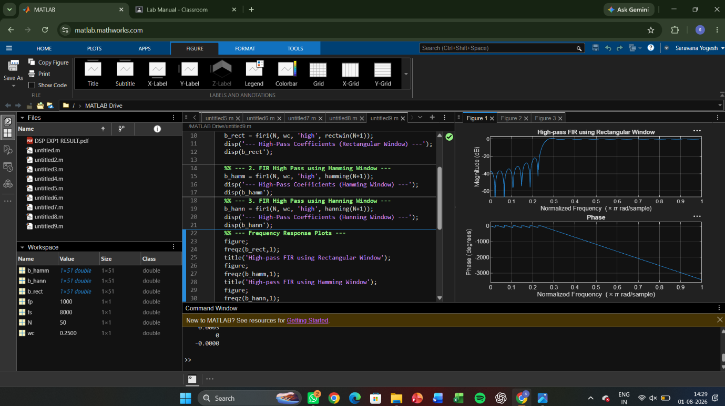

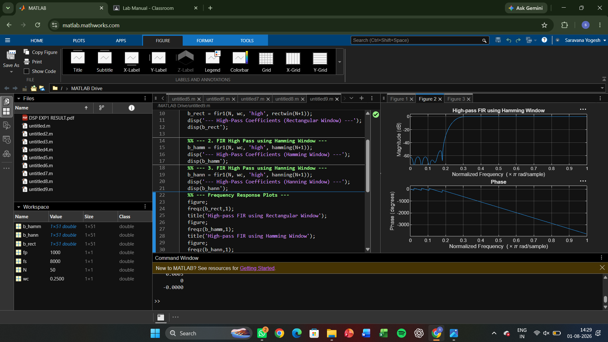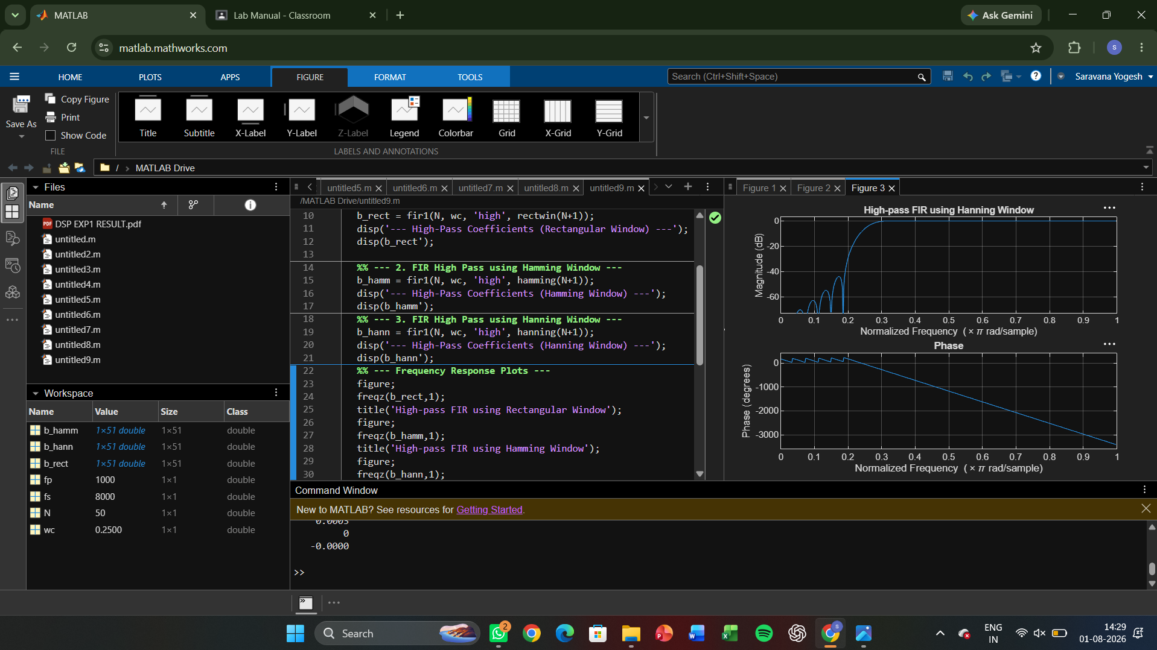

5.2)CODE
clc; clear; close all;
%% --- Input Parameters ---
fp = 1000; % High-pass cutoff frequency (Hz)
fs = 8000; % Sampling frequency (Hz)
N = 50; % Filter order
wc = fp/(fs/2); % Normalized cutoff (0–1)
%% --- FIR High Pass using Hamming Window ---
b_hamm = fir1(N, wc, 'high', hamming(N+1));

disp('--- High-Pass Coefficients (Hamming Window) ---');
disp(b_hamm');
%% --- Frequency Response Plots ---
figure;
freqz(b_hamm,1);
title('High-pass FIR using Hamming Window');
title('High-pass FIR using Hanning Window');

OUTPUT:
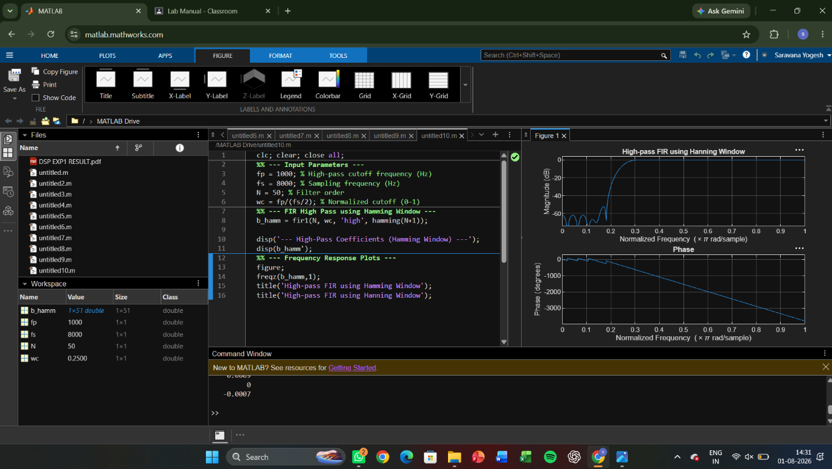

5.3) CODE
clc;
clear;
close all;
%% Signal
fs = 1000; f = 50;
t = 0:1/fs:0.1;
x = sin(2*pi*f*t);
%% Quantization Levels
L = [8 16 32];
colors = {'r','g','m'};
figure;
for i = 1:length(L)

% Plot Quantized Signals
subplot(4,1,i+1);
stairs(t,xq{i},colors{i},'LineWidth',1.2);
title(['Quantized Signal (' num2str(L(i)) ' Levels)']);
grid on;
end
% Original Signal
subplot(4,1,1);
plot(t,x,'LineWidth',1.5);
title('Original Signal'); grid on;
% Display MSE
fprintf('MSE for 8 Levels = %f\n', mse(1));
fprintf('MSE for 16 Levels = %f\n', mse(2));
fprintf('MSE for 32 Levels = %f\n', mse(3));
%% Error Plots
figure;
for i = 1:3
subplot(3,1,i);
plot(t,e{i});
title(['Error (' num2str(L(i)) ' Levels)']);
grid on;
end

OUTPUT:

